**An Introduction to Antenna Analysis and Modeling**

**Part 1: The Basics**

**Najm J. Choueiry, AB1ZA.**

**01.04.2019**

In this introduction to antenna analysis and modeling, I will focus on two well-known software packacges, EZNEC developed by Roy Lewellen W7EL and 4Nec2 by Arie Voors with a heavier emphasis on EZNEC. EZNEC is currently version 6 and a demo version can be downloaded from Roy Lewellen’s website [www.eznec.com](http://www.eznec.com). The EZNEC demo is limited to a maximum number of 20 segments. Even with this limitation, it is a great tool to learn to analyze simple antennas such as dipoles, 3 element yagis or quads. Paid versions of EZNEC extend the maximum number of segments, and the current version of EZNEC+ allows a total of 2000 segments. 4NEC2 is free and does not impose a limitiation on the number of segments. 4NEC2 can be downloaded from https://www.qsl.net/4nec2/.

Both software packages are based on a core calculation engine called NEC2. NEC stands for Numeric Electromagnetics Code, and is a numeric mathematical technique based on the Methods of Moments that calculates the radiation field surrounding an antenna, but summing the field contribution of each segment and pair of segments to generate the field at every angle of elevation and azimuth angle of an antenna. NEC2 was developed at the Lawrence Livermore Laboratory in Livermore California. You can read additional information and see a list of contributors using reference [3].

NEC2 was developed in the 1970’s and ran Fortran code on mainframe computers. Data entry consisted of cards, one statement per card. The program input consists of comment cards, structure geometry input cards and program control cards. The comment cards serve to add one or more comments, the structure geometry describes the physical dimensions and layout of the antenna and the program control cards define additional parameters such as loads, transmission lines, ground type, the design frequency the source type and various commands to calculate radiation fields.

NEC2 describes an antenna in terms of wires consisting of segments. A wire is a straight line, an arc or a circle are approximated by a number of wires connected end to end. A souce connects to a middle of a segment, so to model a dipole a single wire consisting of an odd number of segments is used and the source location will always be at the geometrical center of the wire.

EZNEC and 4NEC2 hide the complexity of entering NEC commands behind a Graphical User Interface (GUI) that is common to modern software. EZNEC does not generate a list of NEC commands but 4NEC2 does. 4NEC2 can open an EZNEC file with an extension of .ez and converts to its internal format .nec.

As an example start EZNEC and open BYDipole.ez.

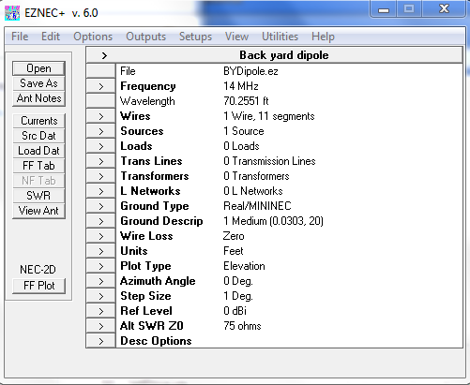

Note: to save the model to a new name use Save As and enter a new name or the same name that you saved previously. EZNEC always uses the Last.ez when it starts.

Click on wires. The dipole consists of 1 wire only with 11 segments. The wire is defined by its starting and ending coordinates (X, Y, Z). The Z coordinate is the height of the antenna above ground unless the ground description is free space.

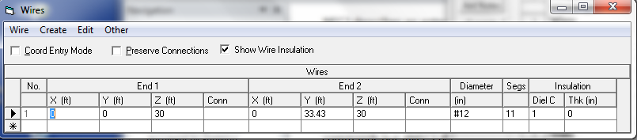

Click on Sources. There is only one current source specified located 50% from end 1 of the antenna.

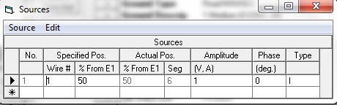

Click Ground Type. The selections are Free Space if you are modeling an antenna in space or when the interactions with ground are negligible. Perfect refers to a completely reflecting ground such as the surface of the sea. Real ground refers to most ground you will be installing an antenna over and consists of High Accuracy and MININEC types. MININEC was developed when computers or laptops didn’t have the CPU power to perform calculations. For all practical purposes nowadays you can use the High Accuracy.

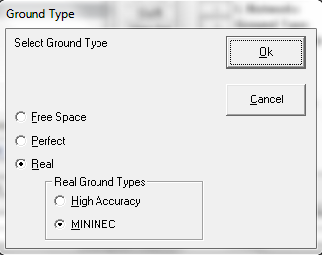

Click Ground Desciption, and right-click while the cursor is in S/m field to open the ground characteristics.

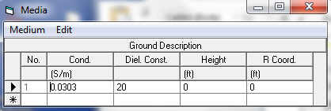

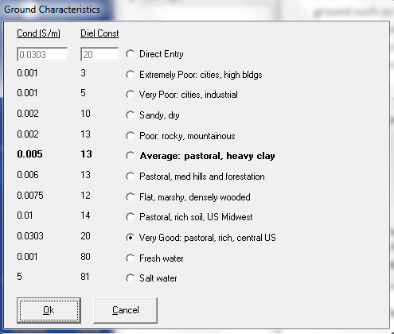

Click Wire Loss to select the type of material to use. The material selected applies to all wires. EZNEC does not have the feature to assign different materials to different wires of an antenna.

. 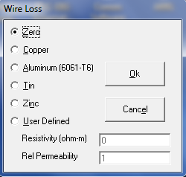

Click Units. EZNEC allows several US units to be used in addtion to the meter which is used for NEC calculations. EZNEC uses the combination feet and inch, or meter and millimeter for wire length and diameter. NEC entries are in meters for both length and radius of the wire. NEC require a radius entry instead of diameter.

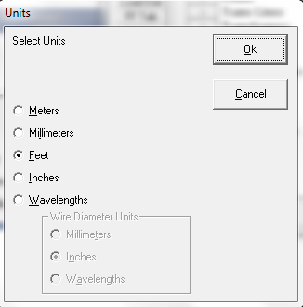

At this point we have defined the geometry of the antenna, the source, the frequency and ground type so let’s see how it translates to NEC code. Click View Antenna. Notice the circle in the middle of wire 1 that indicates the location of the source.

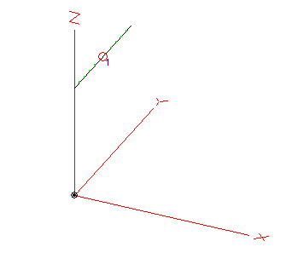

Use Plot type to change plot to 3 Dimensional. Select a step size of 5 degrees. Click FF Plot.

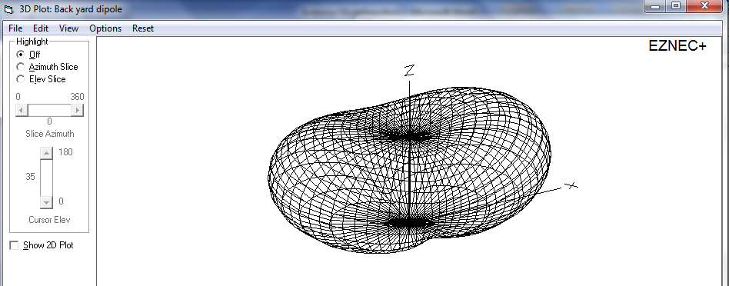

Check the Show 2D Plot. Arrange the winows side by side. Click the Azimuth Slice and change the elevation angl. Notice how the change carries over to the next window.

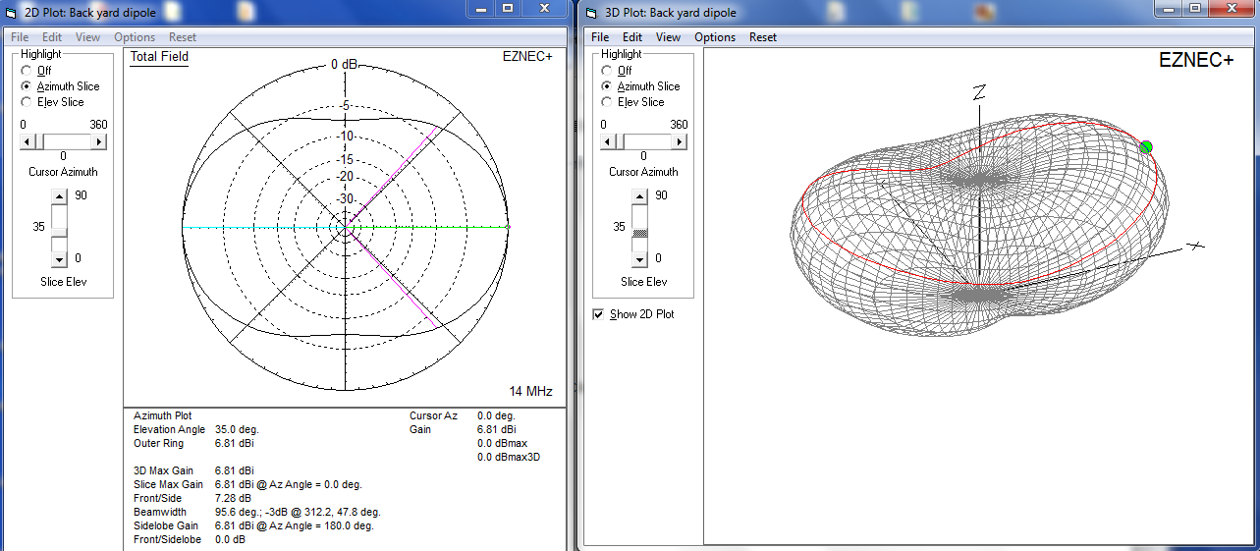

Click the Elevation Slice and chane the Azimuth angle. Notice how the change carries over to the next window.

With the frequency set at 14 MHz. Click the Src Data.

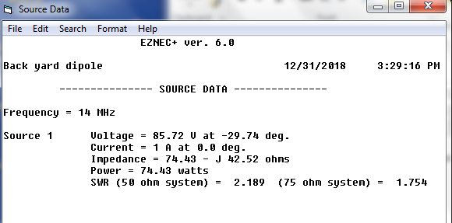

The impedance shows a negative value of –j45.52 ohms and an SWR of 2.189. The antenna is capacitive and shorter than its electrical length. The original length was 33.43 ft. By trial and error changing the length to 34.45 ft reduces the impedance to +j0.3436.

Return the length to 33.43 ft. Click SWR. Enter a start frequency of 13 MHz, a stop frequency of 15 MHz and a step frequency of 0.01 MHz (10 kHz). Click Run.

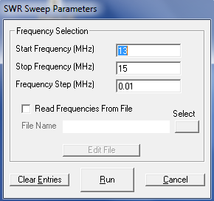

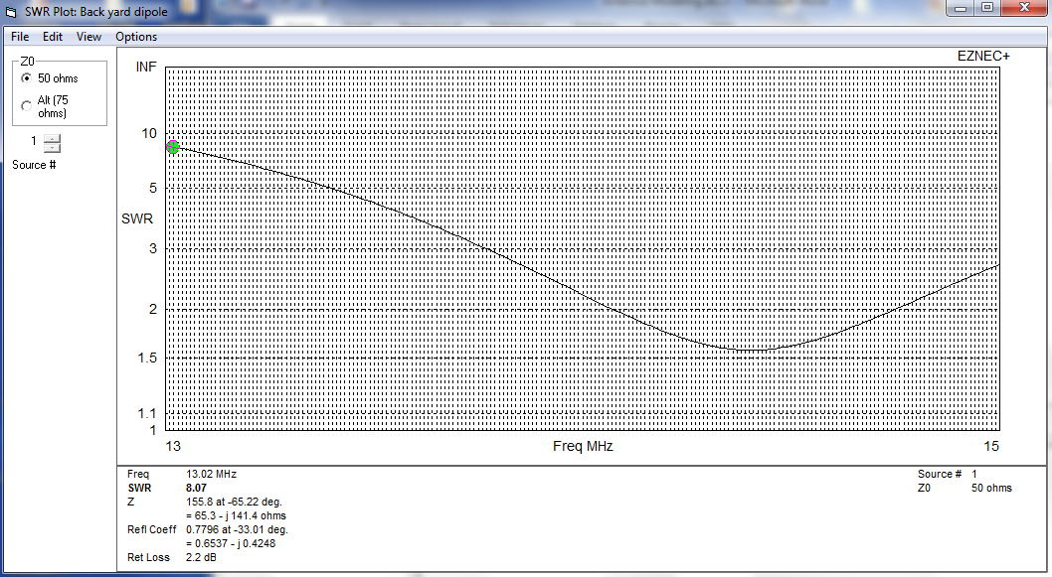

Position the cursor on the green dot and move to change the frequency while noticing the SWR and impedance values.

Start 4NEC2 and use it to open BYDipole.ez. Specify the folder and tpe of file to open. Use the Edit NEC input-file to view the NEC code.

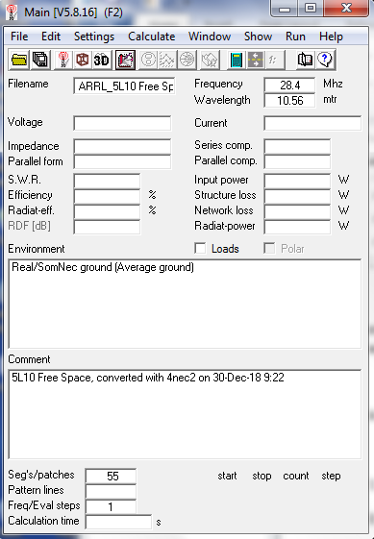

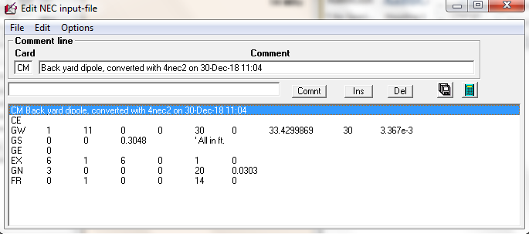

You can highlight all the commands and copy and paste.

CM Back yard dipole, converted with 4nec2 on 30-Dec-18 9:21

CE

GW 1 11 0 0 30 0 33.4299869 30 3.367e-3

GS 0 0 0.3048 ' All in ft.

GE 0

EX 6 1 6 0 1 0

GN 3 0 0 0 20 0.0303

FR 0 1 0 0 14 0

Notice that the program saves only the geometry and some of the parameters related to the antenna. CM and CE are the comments cards. GW is the wire geometry command and defines the id (1) of the wire, the number of segments (11), the starting and ending x, y, z coordinates and the radius of the wire. GS is the geometry scaling factor. Since dimensions were entered in feet a conversion factor of 1 foot = 0.3048 meter is used. The EX, GN and FR commands define the excitation or source, the ground type and the frequency in use (14 MHz).

As an additional example, open ARRL_5L10 Free Space.EZ and use Edit NEC input-file to view the NEC code.

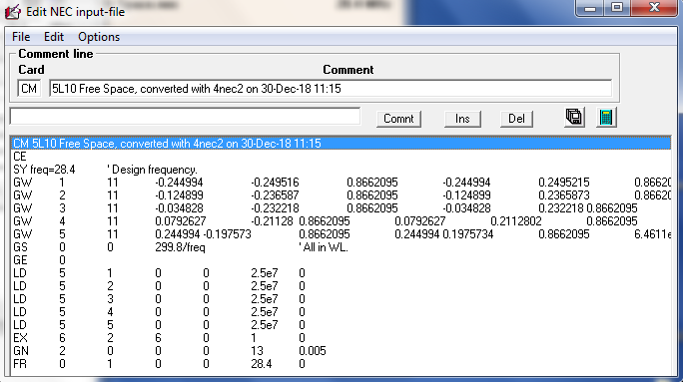

CM 5L10 Free Space, converted with 4nec2 on 30-Dec-18 11:15

CE

SY freq=28.4 ' Design frequency.

GW 1 11 -0.244994 -0.249516 0.8662095 -0.244994 0.2495215 0.8662095 6.2978e-4

GW 2 11 -0.124899 -0.236587 0.8662095 -0.124899 0.2365873 0.8662095 6.2684e-4

GW 3 11 -0.034828 -0.232218 0.8662095 -0.034828 0.232218 0.8662095 6.353e-4

GW 4 11 0.0792627 -0.21128 0.8662095 0.0792627 0.2112802 0.8662095 6.1879e-4

GW 5 11 0.244994 -0.197573 0.8662095 0.244994 0.1975734 0.8662095 6.4611e-4

GS 0 0 299.8/freq ' All in WL.

GE 0

LD 5 1 0 0 2.5e7 0

LD 5 2 0 0 2.5e7 0

LD 5 3 0 0 2.5e7 0

LD 5 4 0 0 2.5e7 0

LD 5 5 0 0 2.5e7 0

EX 6 2 6 0 1 0

GN 2 0 0 0 13 0.005

FR 0 1 0 0 28.4 0

The structure of the NEC file is the same except that multiple GW commands (5) are needed to describe the 5-elemets Yagi. Additional LD commands were also used to specify Aluminum as defined in Wire Loss. The resistivity of Aluminum alloy 6061-T6 is 4.00E-08 Ohm-m. The conductivity is the inverse of the resistivity and equals 0.25E8 or 2.5E7 mhos/m as shown in the LD command. The current units are Siemens/m. Notice also that the NEC allows you to define different materials conductivity for each element.

Geometry tutorial construction.

Open BYDipole.ez and Save As Car.ez

In this example we are going to construct a frame for a car starting at (0,0,0) and ending at (0,0,0). The frame will be built in the Y-Z plane, so the coordinate X will always be zero. Change Units to Inches and Ground to Free Space.

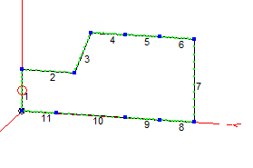

The initial frame consists of 11 segments. Modify wire No. 1 so that the starting point is (0,0,0) and the ending point is (0,0,30). Wire number 1 is vertical and has a length of 30”. Start a new line by positioning the cursor below wire No. 1 and type W1E2. EZNEC will automatically fill in the coordinates of wire 1 end 2 (0, 0, 30) as the starting coordinate of wire 2. Wire 2 is 38” long and lying along the Y axis. In a similar manner, start a new line byu positioning the cursor below wire No.2 and type W2E2. EZNEC will automatically fill in the coordinates of wire 2 end 2 (0, 38, 30) as the starting coordinate of wire 3. Wire 3 extends 12” horizontally and 30” vertically. The coordinate for the end pooint of wire 3 is (0, 50, 60).

Continue filling in the remaining wires. Wires 4, 5, 6, 8, 9, 10, 11 are 25” long each. Wire 7 is 60” long. Your Wires table should look like the one below.

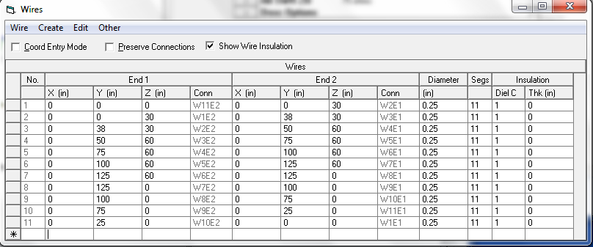

From the wires menu, select Copy Wires… as shown below. By default all the wires are selected 1 through 11. Enter 62 to offset the 11 wires by 62 in the X direction.

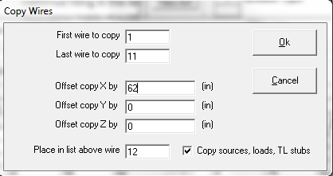

11 new wires have been added offset by 62” in the X direction. The antenna view and wire tables are shown below. Notice also that the source attached to wire 1 has also been copied to wire 12 since the Copy sources, loads, TL stubs checkbox is checked. You can go back to the sources menu and delete the source attached to wire 12.

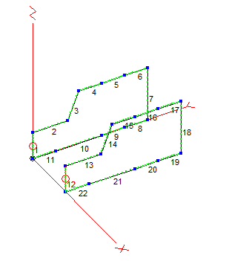

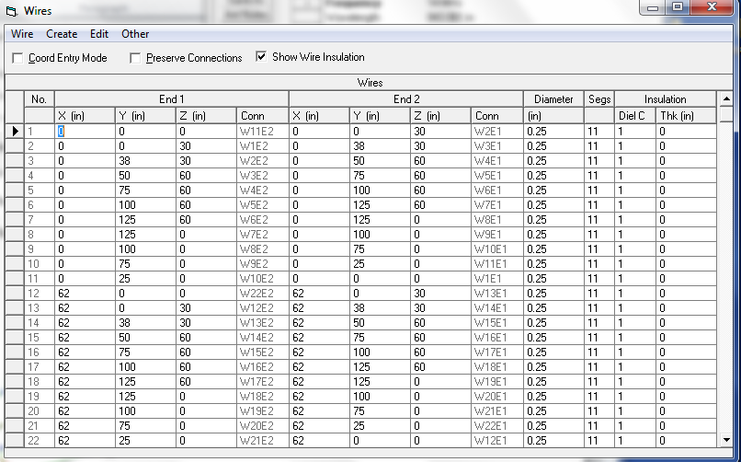

Notice how wires 12 through 22 have the same Y and Z coordinates as wires 1 through 11. Let us lift the car by a foot off the ground. From the menu Wires, Change height by… Notice that all the wires are selected by default. Enter 12 for height change and hit OK.

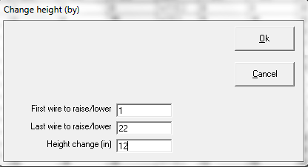

View antenna and notice the change in height.

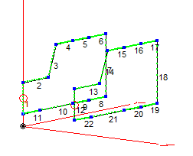

The last step is to connect end points of wires to form a complete frame. In the wire table enter a new wire and specify W1E1 as the starting coordinate and W12E1 as the ending coordinate. Similarly enter a new wire and specify W1E2 as the starting coordinate and W12E2 as the ending coordinate. You antenna view will look like shown below with 2 new wires connected.

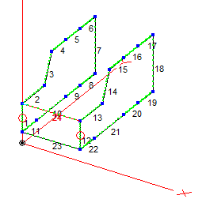

You can proceed in a similar fashion to add additional wires. Or you can use the view antenna window directly. Click on Add Conn Wires. Left click on a point on the frame lying in the Y-X plane, move the cursor to the opposite point, the line will change color. Right click to select the opposite point. Repeat to finish the top of the car as shown below.

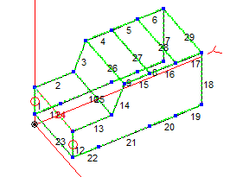

Select Normal Viewing to exit add connection wires mode. Click on Center Ant Image and uing the left mouse rotate the car to get a clearer view of the remaining wires to connect.

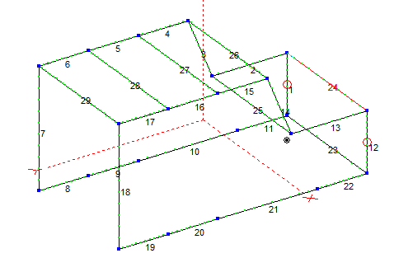

Click on Add Conn Wires and using left click to start and right click to end and add the remaining wires. Click on Normal Viewing to exit add connection wires mode.

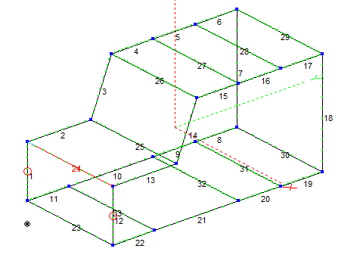

Go back to the control center and notice the number of wires and number of segments used. Depending on your version you might not able to run the model.

As an additional exercise try to build the following tower

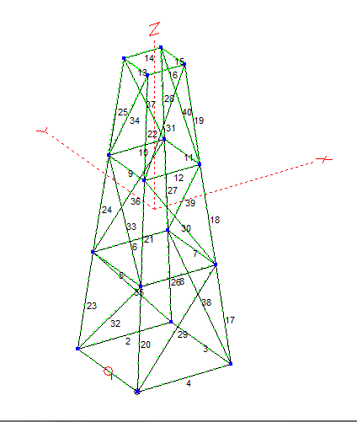

Hints for tower constructions: Create 4 concentric squares. The outer one being 10x10, the next nested one 8x8, then 6x6 and 4x4. 16 wires would have been created. Change the height of wires 5, 6, 7 and 8 to 10 feet high. Change the height of wires 9, 10, 11 and 12 to 20 feet high, and wires 13, 14, 15 and 16 to 30 feet high. View Antenna. Alternate between Add Conn Wires and Normal Viewing to add connecting wires and rotate the tower.

I hope you enjoyed the presentation and added an additional bit of knowledge to your Ham hobby.

Regards, Najm J. Choueiry, AB1ZA.

**References:**

1. **EZNEC v6.0 Roy Lewallen, W7EL**
2. **4NEC2 by Arie Voors**
3. **NEC-2 Manual, Part III, User’s Guide**



1. **Antenna Modeling for Beginners. Ward Silver, N0AX**
2. **How to Start Modeling Antennas using EZNEC, Greg Ordy W8WWV**